MsgViewWin.exe

What is MsgViewWin.exe?
MsgViewWin.exe is a Cerner Millennium tool designed to translate and display information stored in the log files (system.mlg, crmtimer.mlg) created by front-end Cerner Millennium applications. This utility can affect the logging level on your system, and display logged events. This utility is only available if Cerner Millennium is installed on your PC.

What Is The Value Added:
Using this tool with the Crm Timer Log File, we can:
- Track number of front-end calls to scripts in a given time frame.
- View the front-end elapsed time as well as server time at the call (script) level.
- Draw correlations between PC time, server elapsed time, and server CPU time.
- Track exactly what scripts and server steps the application executed.
- View the server number for each script call.
  - Will not show child scripts and scripts called by a server (i.e.: Clinical Event server)
- See what sequence the scripts are called/executed in.
  - Question if there are multiple calls to the same script, in the same step or other steps
  - Question multi-threading, parallelism and asynchronous calls
- Identify the worst script performers in a given step (used in prioritization).
- Create a unique list of scripts for a given step or workflow.
- Export log files to Excel format for reporting purposes.

Setting up MsgViewWin.exe
Before you do anything:
- Ensure that you have Cerner Millennium installed on your PC.
- You will want to delete the crmtimer.mlg file (if one exists), and the system.mlg (if one exists) file from your Cerner directory. (C:\Program Files\Cerner\system.mlg and/or C:\Program Files\Cerner\crmtimer.mlg).

- Start MsgViewWin.exe from the RUN window. i.e.: Go to Start->Run, and then type in “msgviewwin” and then click OK. This will open the MsgViewWin.exe utility.
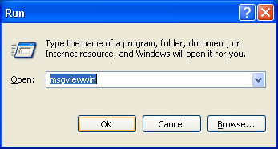

- Go to File-> CrmTimer Is OFF and click on it (If it does not already say CRM Timer is On). The menu should change to say “CrmTimer Is ON”. This option simply toggles whether or not your system is logging events to the CRMTimer.mlg file.
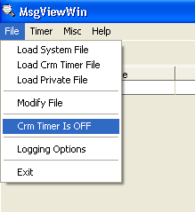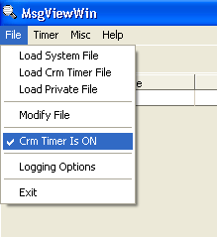

- You can further customize your system’s logging options by going to File->Logging Options. This will allow you to control exactly how much information is gathered from the applications you run on your system.
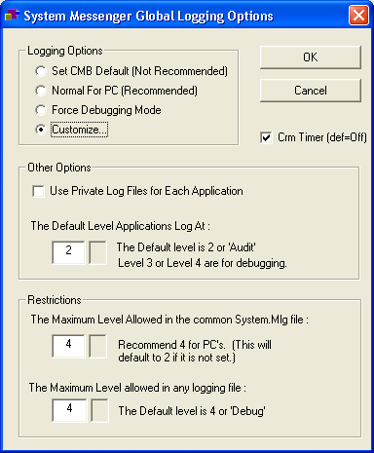

- When you are done setting up logging the way you want MsgViewWin.exe to behave, click OK, and then minimize MsgViewWin.exe on your desktop.

How do I use this utility?
Once you have set up MsgViewWin.exe logging the way you like it:
- Run a Cerner Millennium application for which you want to gather statistics.
- Perform the action that you want metrics for on the Cerner Millennium application; this will populate the CRM Timer log in the crmtimer.mlg and the System log in the system.mlg with the calls from the front-end to the back-end.
- Restore MsgViewWin.exe.
- Now that the crmtimer.mlg is filled with the information you desire, you can choose to export the CRM Timer to a MS Excel spreadsheet. You do this by clicking on “Timer->Export Timer File to Microsoft Excel format”. It will convert the crmtimer.mlg file to an MS Excel format. If you want to avoid this step and just view it in MsgViewWin.exe itself, then please refer to Step 12 of this section.
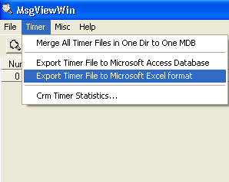

- It will first ask you for the CRM Timer file location which is located at C:\Program Files\Cerner\crmtimer.mlg. 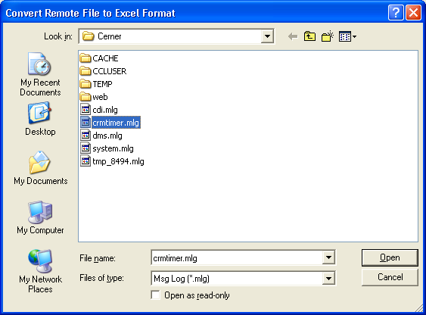

- It will ask you to list a destination to save the MS Excel format file. You can keep it at the same location as the existing crmtimer.mlg file or you can save it anywhere on the PC.
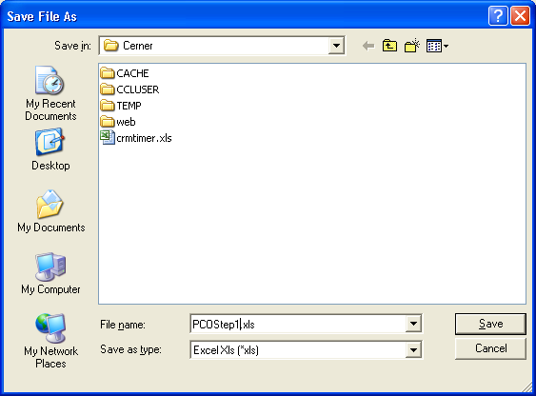

- Once you have populated this information, it should ask if you would like to open the newly created MS Excel file.
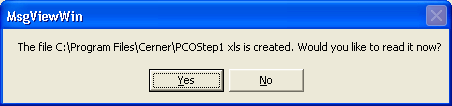

- Click on Yes and it will open the file in MS Excel.
- Now you should be looking at a spreadsheet with a set of information that looks something like this:
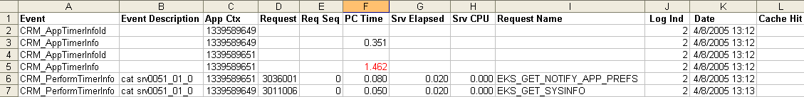

Its columns are identified below:
- The Event Description column gives us the machine name and the server number the request was passed into.
- The Application Context number (App Ctx),
- The Request Number (Request),
- The PC Time (elapsed time, front end; this is not reliable on a system with noise on it),
- The Server elapsed time (Srv Elapsed, the amount of time it took the backend to process the request),
- The amount of the Server’s CPU this process took (Srv CPU),
- The Request Name,
- The date/time that the event occurred. This is where we get the value from this application listed above.
- Cache Hit indicates whether or not the request was stored in the front end cache or not. This relates to Event Description in that if it is a cached hit, it will not be passed to the server.
- If you want to gather statistics on the next step, you must delete the crmtimer.mlg and the system.mlg file from the Cerner Directory (Refer to step 2 from the Setting up MsgViewWin.exe section).
- You can issue the next command from the front-end that you want to gather statistics on, which will re-populate the crmtimer.mlg file. The crmtimer.mlg file can then be exported again, via the same method, so that you have statistics for the next step.

- If you want to look at this information in MsgViewWine.exe itself then, after Step 3, click “File->Load Crm Timer File”.
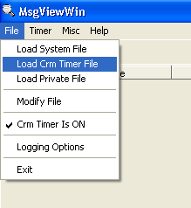

- You will be greeted with the following message:
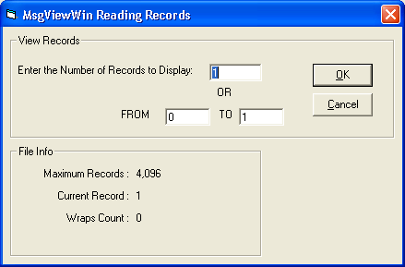

- This screen allows you to display the N most recent records logged to the CRM Timer, or a span from record X to record Y. All of the records up to the maximum records number are stored in the log file; this number just alters how many are displayed to the user.

- Press OK when you have the desired span of records, and MsgViewWin.exe will populate the terminal:
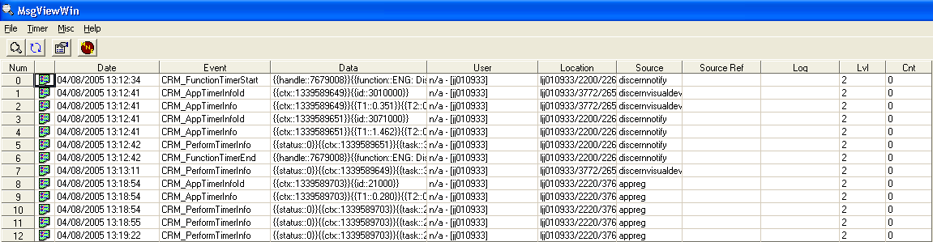

- You can use Step 12 in a similar fashion to view the System File. The System File just shows information logged at the system level, which may or may not be useful when doing detailed timed analysis for a Cerner Millennium application.

Things to note:
- This utility will NOT indicate what child scripts were called from any parent scripts that the front-end executed using the Application-Task-Request (ATR) process.
- The PC Time field is subject to whatever noise is on the PC executing the application; it varies, and is not reliable as a benchmark for performance. For example, if Windows Media player was running, the PC time would be different from a run during which Windows Media player was not running and thus would provide inconsistent results.
- On the other hand, the PC Time field DOES provide a relative standard to judge scripts for an individual application functional step; this is useful for prioritization of poor performing scripts within a given functional step.

